**AHMED HAMED ALY**

18308279

DATE: 2/NOV/2018

LAB: LG35/36

TIME: 4PM TO 6PM

**Introduction**

The experiment consisted of five main parts,

(A) Connecting a circuit using the circuit diagram provided in the question;

(B) Compare the input and output waveforms on the oscilloscope.

(C) Add a capacitor of 1µF to the first circuit diagram parallel to the 10kΩ resistor;

(D) Plot the input and output waveforms for the second circuit and repeat with 200hz and 2Khz and repeat with 10µF capacitor.

(E) Suggest applications for the circuits which are simple ac to dc converters.

There was a couple of factors I had to consider before starting the experiment. These included,

Using working apparatus that has been tested before and won’t cause an error in my result;

Calibrated the oscilloscope using the probes and making sure that line was aligned with the middle;

Understanding what a capacitor is and how it functioned in comparison to the rest of the circuit. A capacitor is a device used to store electric charge (shown below).

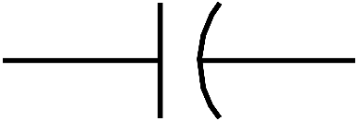

Capacitor

**Objective**

The objective of the experiment is to create a circuit that converts A.C. current to D.C. current using a capacitor.

From what I already know of how a capacitor work. I expect to notice a period of a buildup of charge from the capacitor and a period of discharge when the capacitor is fully charged up. I am hoping to get a graph on the oscilloscope that match the sketch graph below;

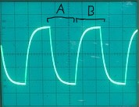

A = period of discharge.

B = period of buildup of charge.

For the different frequencies that was asked in the question (200hz and 2Khz) I expect the 2Khz frequency to mimic that of the 200hz but 10 times faster and more compact. I also expect a longer period of buildup of charge and discharge for the 10µF capacitor than the 1µF capacitor as the 10µF capacitor has a higher capacitance which would allow it to hold 10 time more charge.

**Apparatus**

The apparatus used for the experiment (shown below) were vital to producing the results I acquired from the experiment.

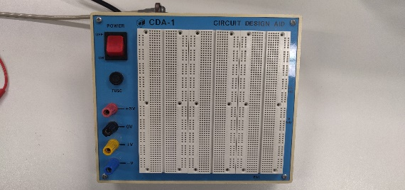 

Breadboard Diode

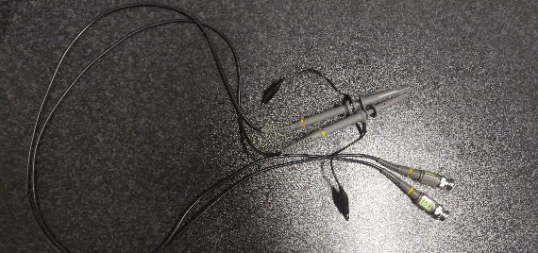 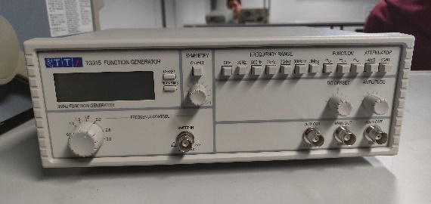

Probes ` Function Generator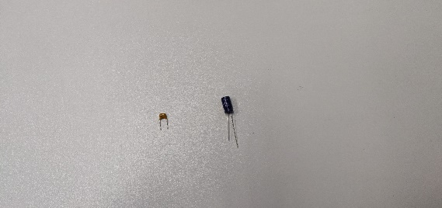 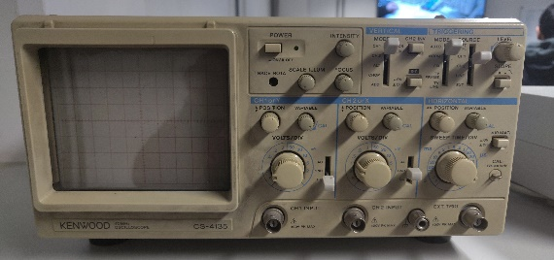

1µF and 10µF Capacitors Oscilloscope

 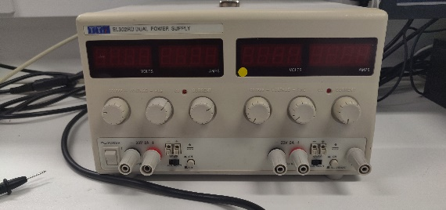

10KΩ Resistor Power Supply

**Method**

1. Connect the circuit (**CIRCUIT 1**) in the diagram shown below.

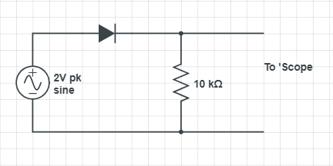

1. I observed the input and output waveforms of the circuit which was caused by diode.
2. Connect the circuit (**CIRCUIT 2**) in the diagram show below by adding a 1µF Capacitor parallel to the resistor.

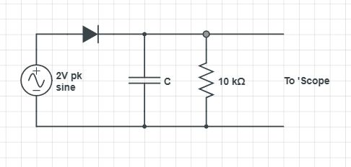

1. I recorded the input and output waveforms which was produced by the charging of the capacitor and its discharge at 200hz and at 2Khz.
2. I repeated the steps 3 and 4 but replaced the 1µF capacitor with a 10µF capacitor.

**Data/Graph**

Input Waveform: **Circuit 1 & Circuit 2;**

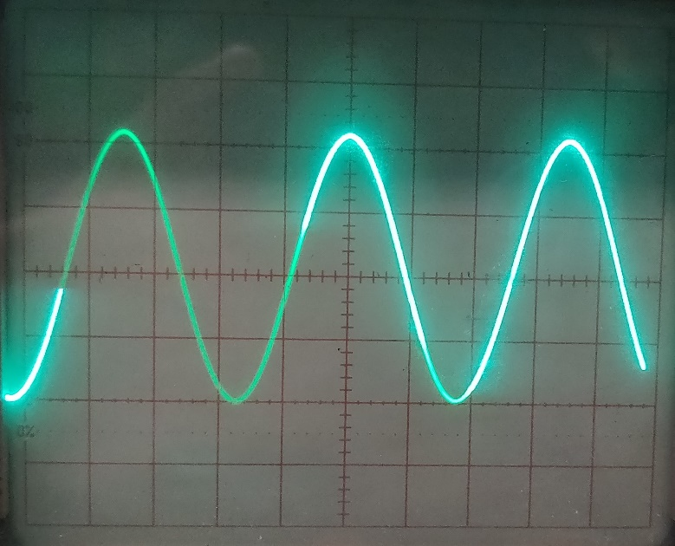

**Circuit 1:**

Output Waveform:

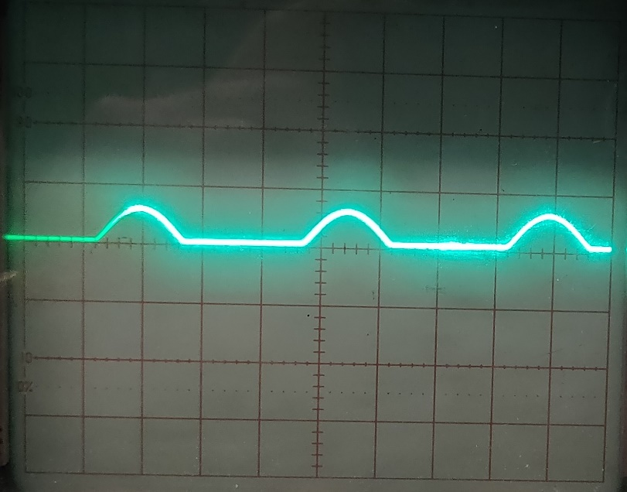

**Circuit 2:**

Output Waveform: 1µF @ 200hz Output Waveform: 1µF @ 2Khz 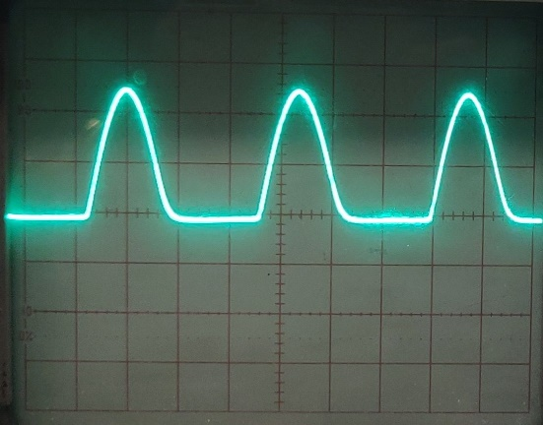 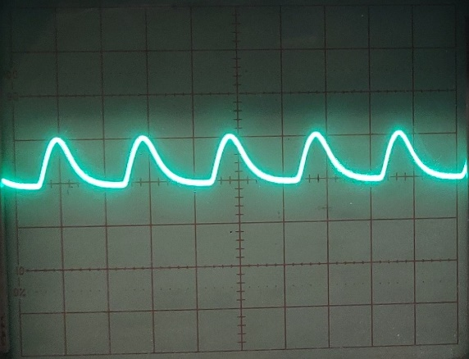

Output Waveform: 10µF @ 200hz Output Waveform: 10µF @ 2Khz

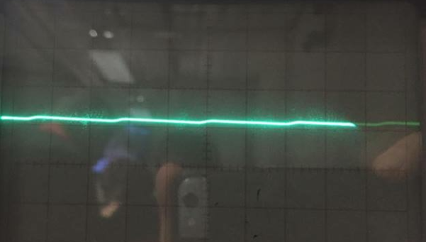 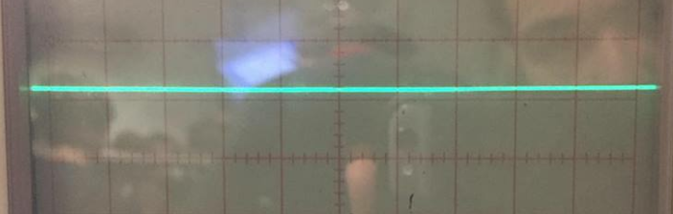

**Data Analysis**

From my results for circuit 1 I observed that the input waveform was a sine wave while the output waveform acted as a short open circuit when I added the diode. This means that it allows no current to flow through it. This was demonstrated in my graph as only half the waveform can be seen while the rest is a flatline.

For circuit 2 I observed that the input waveform was also a sine wave while the output waveform for the 1µF capacitor showed the capacitor building up a charge for 1 half cycle after the half cycle, it didn’t allow any more current to flow through the capacitor, so it discharged and can be seen by the gentle drop in the graph for the 200hz waveform. Like the 200hz waveform, the 2Khz waveform did that of the 200hz waveform but 10 times faster which was displayed by the increased amount of building charge and discharge by the capacitor.

When I replaced the 1µF capacitor with a 10µF capacitor I noticed different output waveforms. The 10µF capacitor has 10 times more capacitance than the 1µF capacitor so it was building up charge for a longer period of time and discharged it over an even longer period of time than the previous 1µF capacitor which resulted in a straighter line for the 200hz waveform. At 2Khz, I observed almost a straight line as it was much faster that it was difficult to differentiate it from a D.C. signal.

There are many **uses** for such a circuit. The circuits above both demonstrated a simple A.C. to D.C. converter. These converters can be used in a variety of things such as powering TVs as that requires a D.C. current rather than an A.C. current which is done through rectifiers, also charging up portable devices that require a constant charge and most electronics that require a D.C. current.

**Conclusion**

In conclusion, the above data and data analysis show that the circuits above are a simple A.C. to D.C. signal converter. Such a circuit can be used for many different devices as outlined above which make these circuits very useful for everyday applications.

**References**

<https://www.scribd.com/doc/12936752/Physics-222-Ohm-s-Law-Lab-Report>

<https://www.circuitlab.com/>

https://electronicsclub.info/circuitsymbols.htm

<https://ac-dc.power.com/applications/>

<https://www.electronics-tutorials.ws/connectivity/ac-dc-converters.html>

<https://learn.sparkfun.com/tutorials/alternating-current-ac-vs-direct-current-dc/all>

<https://courses.umass.edu/plecprep/em/5f3020.html>